Watson Tong
Exercise 1:

//Program Convert converts a temperature in Fahrenheit to
//Celsius and a termperature in Celsius to Farenheit.

#include <iostream>
using namespace std;

const int TEMP_IN_F = 32;
const int TEMP_IN_C = 0;

int main ()
{
int fToC; //Place to store Celsius answer
int cToF; // Place to store the Fahrenheit answer

cToF = (9 * TEMP_IN_C / 5) + 32;
fToC = 5 * (TEMP_IN_F - 32) /9;
cout << TEMP_IN_F << " in Fahrenheit is " << fToC
<< " in Celsius. " << endl;

return 0;
}

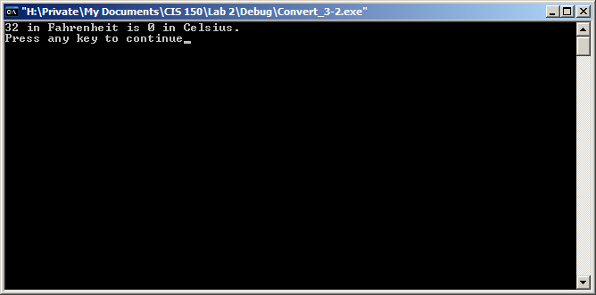

Exercise 2:
//Program Convert converts a temperature in Fahrenheit to
//Celsius and a termperature in Celsius to Farenheit.

#include <iostream>
using namespace std;

const int TEMP_IN_F = 32;
const int TEMP_IN_C = 0;

int main ()
{
int fToC; //Place to store Celsius answer
int cToF; // Place to store the Fahrenheit answer

cToF = (9 * TEMP_IN_C / 5) + 32;
fToC = 5 * (TEMP_IN_F - 32) /9;
cout << TEMP_IN_F << " in Fahrenheit is " << fToC
<< " in Celsius. " << endl;
cout << TEMP_IN_C << " in Celsius is "<<cToF
<< " in Fahrenheit. " << endl;

return 0;
}

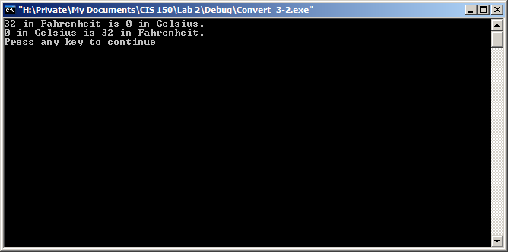

Exercise 3:

TEMP_IN_F | TEMP_IN_C | fToC | cToF
a. 212 | 100 | 100 | 212
b. 100 | 50 | 37 | 122
c. 122 | 37 | 50 | 98
d. 500 | 200 | 260 | 392

//Program Convert converts a temperature in Fahrenheit to
//Celsius and a termperature in Celsius to Farenheit.

#include <iostream>
using namespace std;

const int TEMP_IN_F = 212;
const int TEMP_IN_C = 100;

int main ()
{
int fToC; //Place to store Celsius answer
int cToF; // Place to store the Fahrenheit answer

cToF = (9 * TEMP_IN_C / 5) + 32;
fToC = 5 * (TEMP_IN_F - 32) /9;
cout << TEMP_IN_F << " in Fahrenheit is " << fToC
<< " in Celsius. " << endl;
cout << TEMP_IN_C << " in Celsius is "<<cToF
<< " in Fahrenheit. " << endl;

return 0;
}

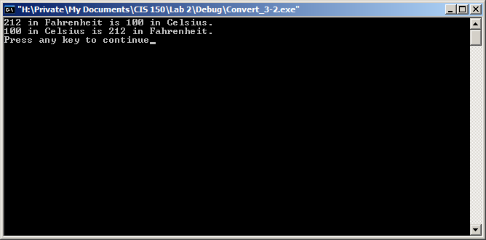

//Program Convert converts a temperature in Fahrenheit to
//Celsius and a termperature in Celsius to Farenheit.

#include <iostream>
using namespace std;

const int TEMP_IN_F = 100;
const int TEMP_IN_C = 50;

int main ()
{
int fToC; //Place to store Celsius answer
int cToF; // Place to store the Fahrenheit answer

cToF = (9 * TEMP_IN_C / 5) + 32;
fToC = 5 * (TEMP_IN_F - 32) /9;
cout << TEMP_IN_F << " in Fahrenheit is " << fToC
<< " in Celsius. " << endl;
cout << TEMP_IN_C << " in Celsius is "<<cToF
<< " in Fahrenheit. " << endl;

return 0;
}

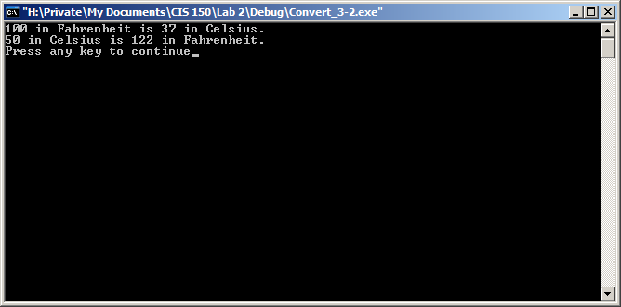

//Program Convert converts a temperature in Fahrenheit to
//Celsius and a termperature in Celsius to Farenheit.

#include <iostream>
using namespace std;

const int TEMP_IN_F = 122;
const int TEMP_IN_C = 37;

int main ()
{
int fToC; //Place to store Celsius answer
int cToF; // Place to store the Fahrenheit answer

cToF = (9 * TEMP_IN_C / 5) + 32;
fToC = 5 * (TEMP_IN_F - 32) /9;
cout << TEMP_IN_F << " in Fahrenheit is " << fToC
<< " in Celsius. " << endl;
cout << TEMP_IN_C << " in Celsius is "<<cToF
<< " in Fahrenheit. " << endl;

return 0;
}

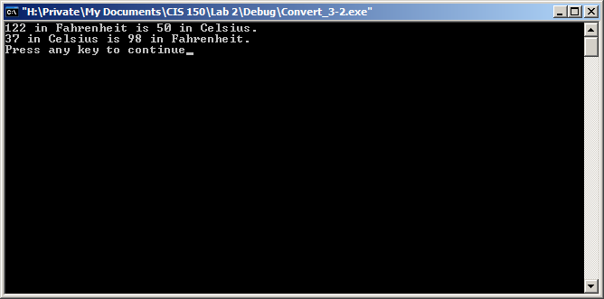

//Program Convert converts a temperature in Fahrenheit to
//Celsius and a termperature in Celsius to Farenheit.

#include <iostream>
using namespace std;

const int TEMP_IN_F = 500;
const int TEMP_IN_C = 200;

int main ()
{
int fToC; //Place to store Celsius answer
int cToF; // Place to store the Fahrenheit answer

cToF = (9 * TEMP_IN_C / 5) + 32;
fToC = 5 * (TEMP_IN_F - 32) /9;
cout << TEMP_IN_F << " in Fahrenheit is " << fToC
<< " in Celsius. " << endl;
cout << TEMP_IN_C << " in Celsius is "<<cToF
<< " in Fahrenheit. " << endl;

return 0;
}

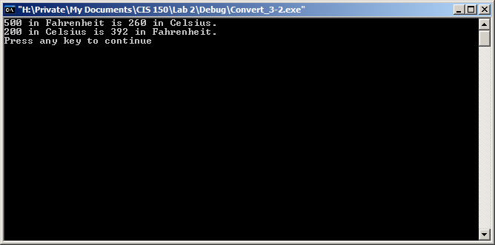

Exercise 4:

The inconsistency between parts b and c involve conversions whose values, when evaluated in the formulas, do not “match” with each other. i.e. 100 F converts to 37 C, but 37 C converts to 98 F.

The problem is due to the fact that the expressions are stored in integers. This type of function will truncate the values of the computations. It would be fixed by using a float type variable.

Exercise 5:

//Program Convert converts a temperature in Fahrenheit to
//Celsius and a termperature in Celsius to Farenheit.

#include <iostream>
using namespace std;

const float TEMP_IN_F = 100;
const float TEMP_IN_C = 50;

int main ()
{
float fToC; //Place to store Celsius answer
float cToF; // Place to store the Fahrenheit answer

cToF = (9 * TEMP_IN_C / 5) + 32;
fToC = 5 * (TEMP_IN_F - 32) /9;
cout << TEMP_IN_F << " in Fahrenheit is " << fToC
<< " in Celsius. " << endl;
cout << TEMP_IN_C << " in Celsius is "<<cToF
<< " in Fahrenheit. " << endl;

return 0;
}

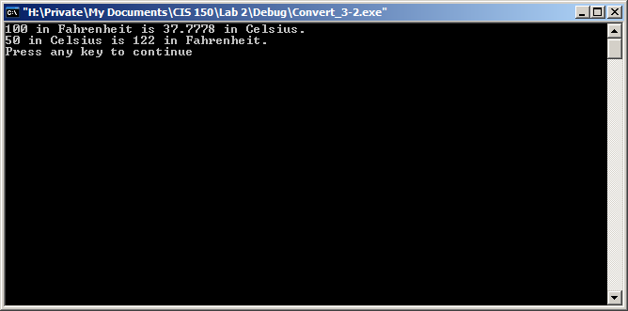

//Program Convert converts a temperature in Fahrenheit to
//Celsius and a termperature in Celsius to Farenheit.

#include <iostream>
using namespace std;

const float TEMP_IN_F = 122;
const float TEMP_IN_C = 37;

int main ()
{
float fToC; //Place to store Celsius answer
float cToF; // Place to store the Fahrenheit answer

cToF = (9 * TEMP_IN_C / 5) + 32;
fToC = 5 * (TEMP_IN_F - 32) /9;
cout << TEMP_IN_F << " in Fahrenheit is " << fToC
<< " in Celsius. " << endl;
cout << TEMP_IN_C << " in Celsius is "<<cToF
<< " in Fahrenheit. " << endl;

return 0;
}

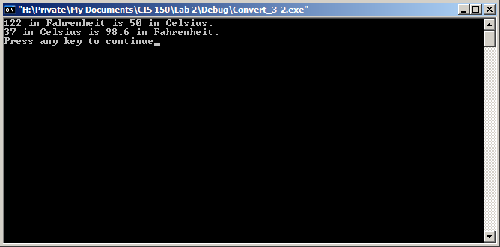

The results confirm my hypothesis.

Exercise 6:

//Program Convert converts a temperature in Fahrenheit to
//Celsius and a termperature in Celsius to Farenheit.

#include <iostream>
using namespace std;

const float TEMP_IN_F = 122;
const float TEMP_IN_C = 37;

int main ()
{
float fToC; //Place to store Celsius answer
float cToF; // Place to store the Fahrenheit answer

cToF = 9 * TEMP_IN_C / 5 + 32;
fToC = 5 * TEMP_IN_F - 32 /9;
cout << TEMP_IN_F << " in Fahrenheit is " << fToC
<< " in Celsius. " << endl;
cout << TEMP_IN_C << " in Celsius is "<<cToF
<< " in Fahrenheit. " << endl;

return 0;
}

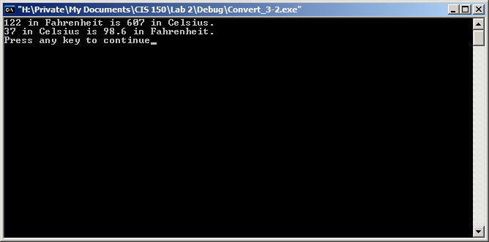

The results are not the same because the evaluated values must follow order of operation. The parentheses have a higher precedence than multiplication and division; they are able to modify the how the equation carries out. By removing those, the line with fToC will first multiply TEMP_IN_F by 5, then divide 32 by 9, and then subtract the two values.

LESSON 3-3:

// Program Numbers sends numbers to the output stream in
// specified formats.

#include <iostream>
#include <iomanip>
using namespace std;

const int a = 1066;
const int b = 1492;
const int c = 512;
const int d = 1;
const int e = -23;

int main ( )

{
cout<< fixed << showpoint << setw(80) << a << endl;
cout<< fixed << showpoint << setw(80) << b << endl;
cout<< fixed << showpoint << setw(80) << c << endl;
cout<< fixed << showpoint << setw(80) << d << endl;
cout<< fixed << showpoint << setw(80) << e << endl;
system("PAUSE");
return 0;
}

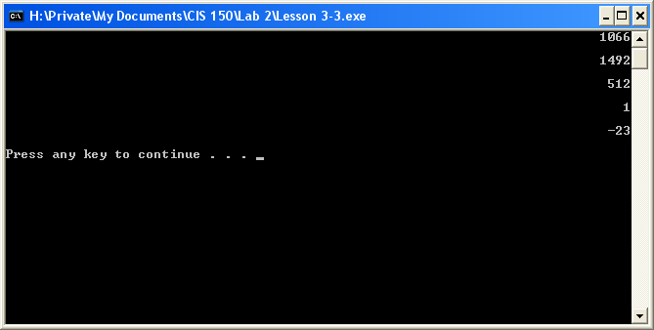

Exercise 2:

// Program Numbers sends numbers to the output stream in
// specified formats.

#include <iostream>
#include <iomanip>
using namespace std;

const int a = 1066;
const int b = 1492;
const int c = 512;
const int d = 1;
const int e = -23;

int main ( )

{
float answer;

cout<< fixed << showpoint << setw(80) << a << endl;
cout<< fixed << showpoint << setw(80) << b << endl;
cout<< fixed << showpoint << setw(80) << c << endl;
cout<< fixed << showpoint << setw(80) << d << endl;
cout<< fixed << showpoint << setw(80) << e << endl;

answer = (float(a + b)) / (float(c + d + e));
cout << setprecision(4) << answer << endl;

system("PAUSE");
return 0;
}

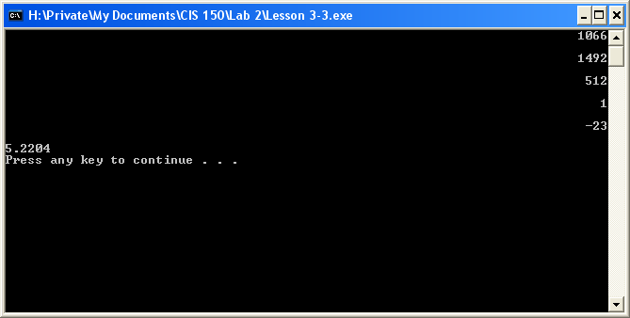

Exercise 3:

// Program Numbers sends numbers to the output stream in
// specified formats.

#include <iostream>
#include <iomanip>
using namespace std;

const float a = 23.62;
const float b = 46.0;
const float c = 43.4443;
const float d = 100.1;
const float e = 98.98;

int main ( )

{

cout<< fixed << showpoint << setw(80) << setprecision(2) << a << endl;
cout<< fixed << showpoint << setw(80) << setprecision(2) << b << endl;
cout<< fixed << showpoint << setw(80) << setprecision(2) << c << endl;
cout<< fixed << showpoint << setw(80) << setprecision(2) << d << endl;
cout<< fixed << showpoint << setw(80) << setprecision(2) << e << endl;

system("PAUSE");
return 0;
}

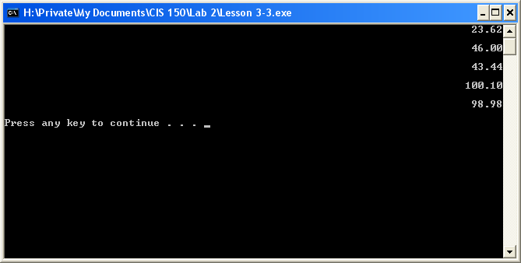

Exercise 4:

// Program Numbers sends numbers to the output stream in
// specified formats.

#include <iostream>
#include <iomanip>
using namespace std;

const float a = 23.62;
const float b = 46.0;
const float c = 43.4443;
const float d = 100.1;
const float e = 98.98;

int main ( )

{
float sum;

cout<< fixed << showpoint << setw(80) << setprecision(2) << a << endl;
cout<< fixed << showpoint << setw(80) << setprecision(2) << b << endl;
cout<< fixed << showpoint << setw(80) << setprecision(2) << c << endl;
cout<< fixed << showpoint << setw(80) << setprecision(2) << d << endl;
cout<< fixed << showpoint << setw(80) << setprecision(2) << e << endl;

sum = a + b + c + d + e;
cout<< “The sum of the numbers is ” << sum << endl;

system("PAUSE");
return 0;
}

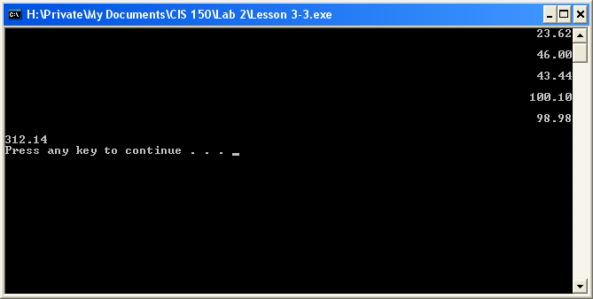

Exercise 5:

// Program Numbers sends numbers to the output stream in
// specified formats.

#include <iostream>
#include <iomanip>
#include <string>
using namespace std;

string morning = "Good Morning";
string sarah = "Sarah";
string sunshine = "Sunshine!";
string myString;

int main ( )
{

cout << " " << morning << " " << " " << sarah
<< " " << " " << sunshine << " " << endl;

system("PAUSE");
return 0;
}

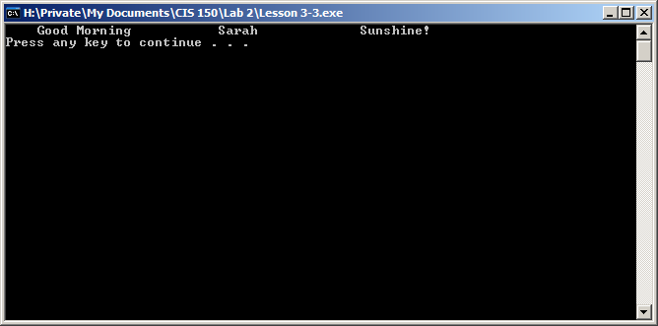

Exercise 6:

// Program Numbers sends numbers to the output stream in
// specified formats.

#include <iostream>
#include <iomanip>
#include <string>
using namespace std;

string morning = "Good Morning";
string sarah = "Sarah";
string sunshine = "Sunshine!";
string myString;

int main ( )
{
cout << setw(16) << morning << setw(16) << sarah
<< setw(22) << sunshine << endl;

system("PAUSE");
return 0;
}

I wasn’t too sure what the exercise asked. This is some additional coding that I performed to make sure that the output aligned exactly with what was done in Exercise 5. The numbers are there to show that there were 20 characters in total (using spaces and the string).

// Program Numbers sends numbers to the output stream in
// specified formats.

#include <iostream>
#include <iomanip>
#include <string>
using namespace std;

string morning = "Good Morning";
string sarah = "Sarah";
string sunshine = "Sunshine!";
string myString;

int main ( )
{
cout << " " << morning << " " << " " << sarah
<< " " << " " << sunshine << " " << endl;

cout << setw(16) << morning << setw(16) << sarah
<< setw(22) << sunshine << endl;
cout << "12345678901234567890"<< endl;
cout << " "<<"1234567901234567890"<< endl;
cout << " "<<" "<<"1234567901234567890"<< endl
<< endl;

system("PAUSE");
return 0;
}
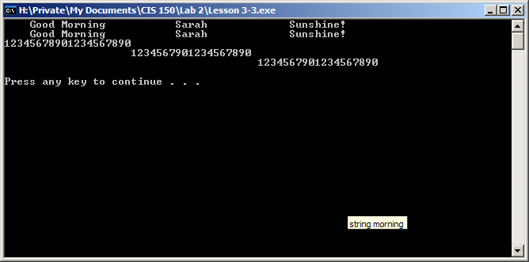

Exercise 7:

// Program Numbers sends numbers to the output stream in
// specified formats.

#include <iostream>
#include <iomanip>
#include <string>
using namespace std;

string morning = "Good Morning";
string sarah = "Sarah";
string sunshine = "Sunshine!";
string myString;

int main ( )
{
cout << setw(16) << morning << endl
<< endl << setw(12) << sarah <<endl
<< endl << setw(14) << sunshine << endl;

system("PAUSE");
return 0;
}

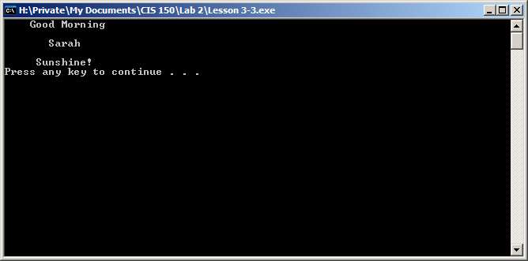

LESSON 5-2:

Exercise 1:
// Program Shell1 prints appropriate messages based on a
// grade read from the keyboard.

#include <iostream>;
using namespace std;

int main ()
{
int grade;

cout << "Enter an integer grade between 50 and 100."
<< " Press return. " << endl;
cin >> grade;

if (grade >= 80)
cout << "Congratulations!" << endl;

system("PAUSE");
return 0;
}

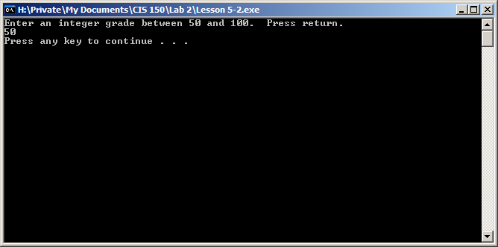
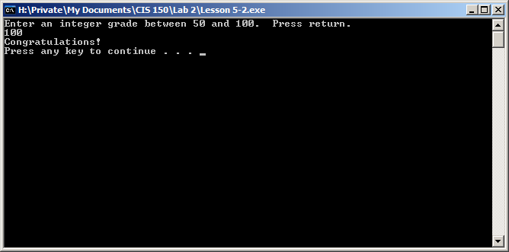
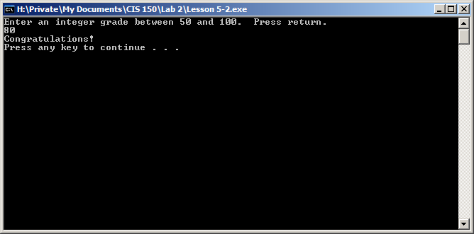
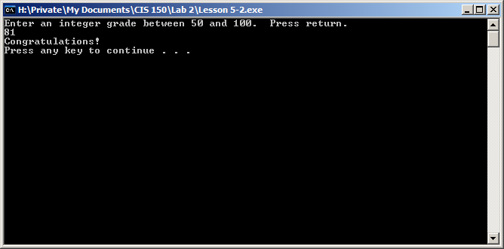
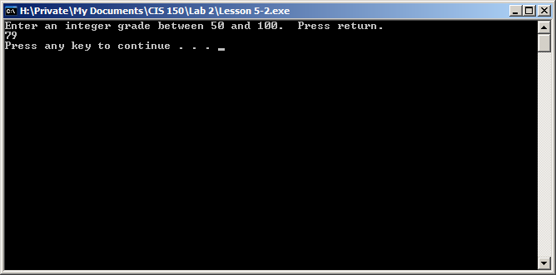

“Congratulations!” is printed three times in the five runs.
Exercise 2:

// Program Shell1 prints appropriate messages based on a
// grade read from the keyboard.

#include <iostream>
using namespace std;

int main ()
{
int grade;

cout << "Enter an integer grade between 50 and 100."
<< " Press return. " << endl;
cin >> grade;

if (grade>= 80)
cout << "Congratulations!" << endl;
else if(grade < 70)
cout << "Try harder" << endl;
system("PAUSE");
return 0;
}

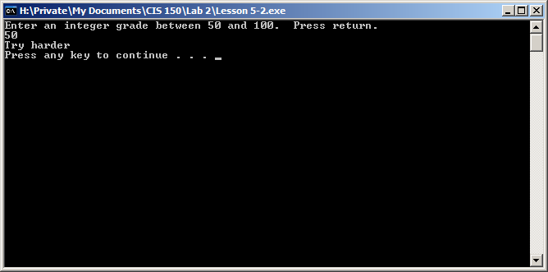
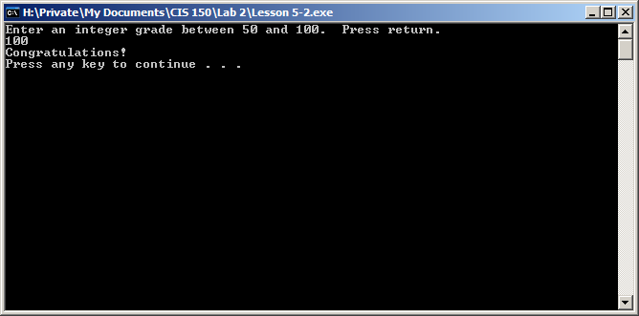
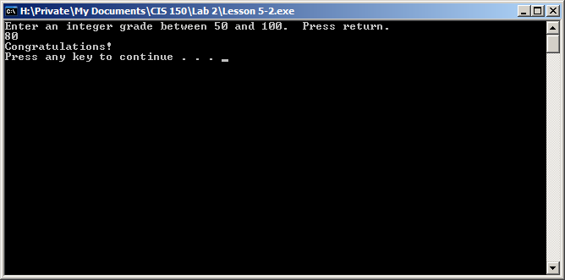

“Try harder” is printed one time in the five runs.

Exercise 3:

// Program Shell1 prints appropriate messages based on a
// grade read from the keyboard.

#include <iostream>
using namespace std;

int main ()
{
int grade;

cout << "Enter an integer grade between 50 and 100."
<< " Press return. " << endl;
cin >> grade;

if (grade>= 80)
cout << "Congratulations!" << endl;
else if (grade < 70)
cout << "Try harder" << endl;
else if (grade <= 80 && grade > 70)
cout << "Average" << endl;

system("PAUSE");
return 0;
}

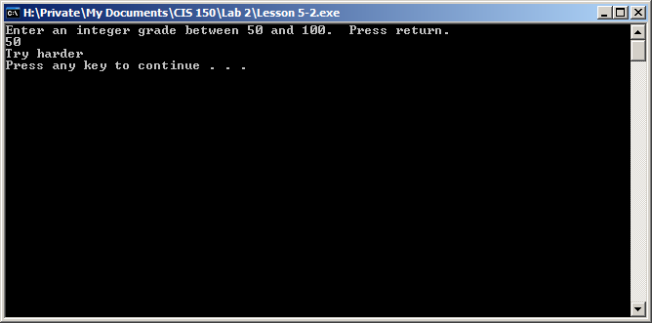
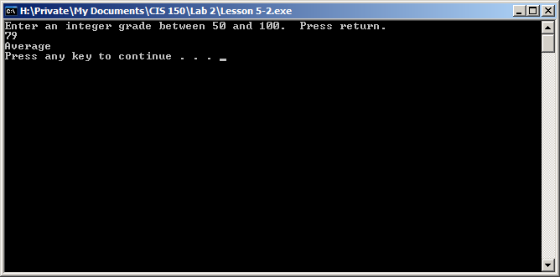

“Average” is printed one time in the five runs.

